
SAFE OPERATING PROCEDURE

Battery Drill
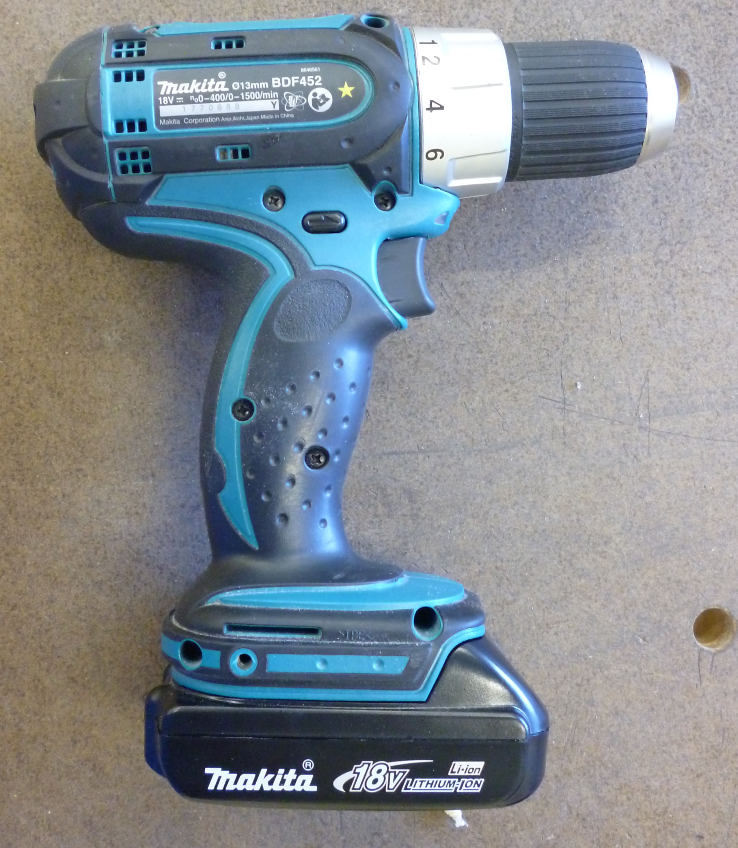
DO NOT use this cordless tool unless you have had instruction and training
in its safe use and operation.

Teacher permission MUST be given

to operate this cordless tool.
The risk of injury when using this machine is LOW

IDENTIFIED RISKS AND HAZARDS
Hazards that may arise when operating the battery drill include:
- moving and rotating parts (drill bits and chuck)
- movement of the workpiece
- inhalation of fumes and dust particles
- ejection of waste materials from cutting blades
- burns from hot materials or friction

PRE-OPERATIONAL SAFETY
- Before using the battery drill, examine the casing for damage.
- Do not use blunt or damaged drill bits.
- Do not test drill bits for sharpness with the fingers.
- Always inspect the workpiece to ensure that there aren't any items which might damage the drill bit or cause injury to the operator.
- Secure and support the workpiece using clamps, bench vices or appropriate weights.

OPERATING SAFETY PRECAUTIONS
- Keep fingers and hands clear of the drill bit.
- Never make adjustments while the battery drill is running.
- When the drill bit has reached the operating speed, apply the load gradually.
- Avoid blocking or covering the motor ventilation slots while using the battery drill.
- Never drill pieces of material by holding them in the hands.
- Hold the drill firmly and exert care when the drill bit begins to break through the workpiece
- Never operate the charger with a damaged cord or plug.
- Be aware not to operate the charger anywhere near water.

 |  |  |  |  |  |  | 



