
SAFE OPERATING PROCEDURE
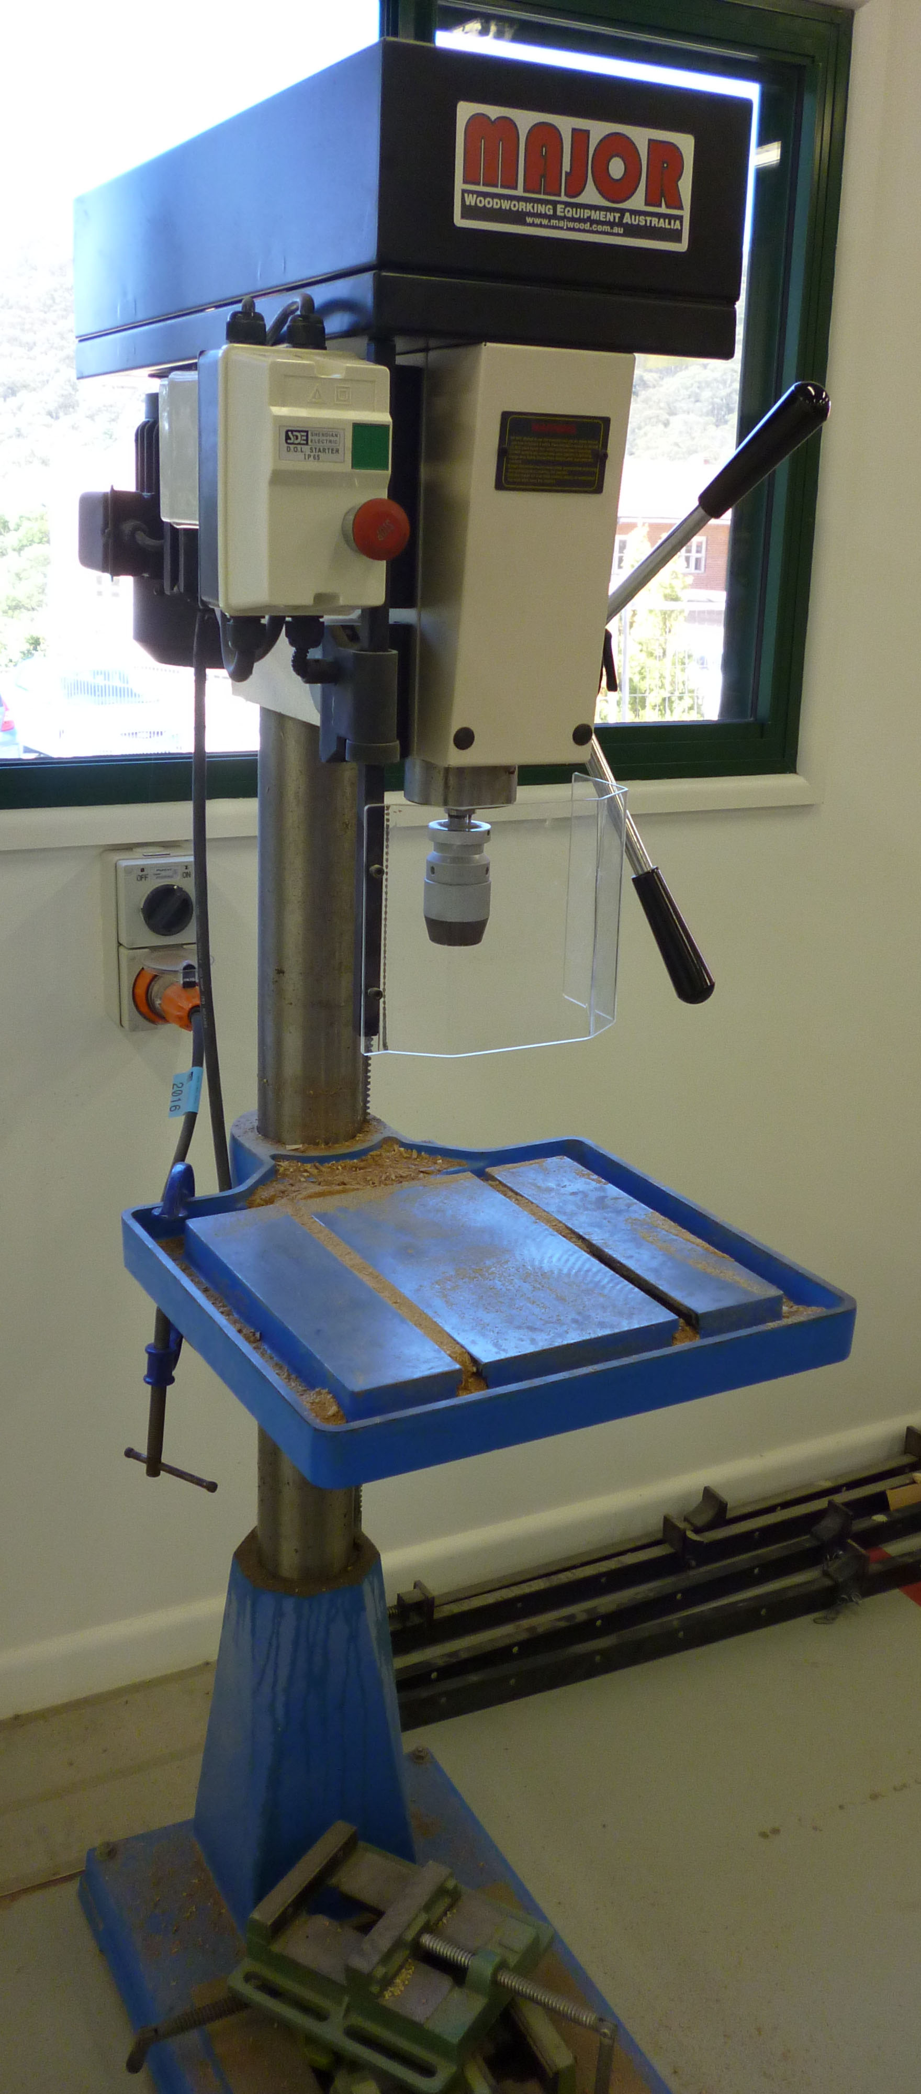

Bench/Pedestal Drill
DO NOT use this machine unless you have had instruction and training
in its safe use and operation.

Teacher permission MUST be given

to operate this machine.
The risk of injury when using this machine is MODERATE

IDENTIFIED RISKS AND HAZARDS
Hazards that may arise when operating the drilling machine include:
- movement of the workpiece
- inhalation of dust particles
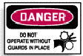
- ejection of waste materials from cutting blades
- hand and finger injuries from rotating drills, spindles or pulleys
- electrocution from equipment or cords
- squash, pinch and crush injuries

PRE-OPERATIONAL SAFETY
- The isolating switch should be in the OFF position. The machine must be isolated from the main electricity supply when not in use.
- Check that drill speed is suitable for the work to be done and adjust as required.
- Check the condition of the drill bits. They should be kept sharp at all times and free of burrs on the shank.
- All guards should be correctly fitted and secured.
- Check all adjustments and settings carefully before commencing any drilling or boring operations.
- The drilling machine and work area should be clean and free of wood chips and other obstacles.

OPERATING SAFETY PRECAUTIONS
- If the machine is not fitted with a keyless chuck, tighten the chuck uniformly when the drill is inserted and always use the correct size chuck key.
- Remove the key from the chuck before starting the drill press.
- Allow the drill bit to cut at its own speed without applying excessive pressure.
- Irregular shaped work should be securely held in a jig, vice or clamp.
- Seek assistance when handling long lengths of timber or sheets.
- Keep the hands clear of the drill bit when the drilling machine is operating.
- Do not remove waste material from the drilling table while the machine is operating.

 |  |  |  |  |  |  | 



