
SAFE OPERATING PROCEDURE

Bench/Pedestal Grinder
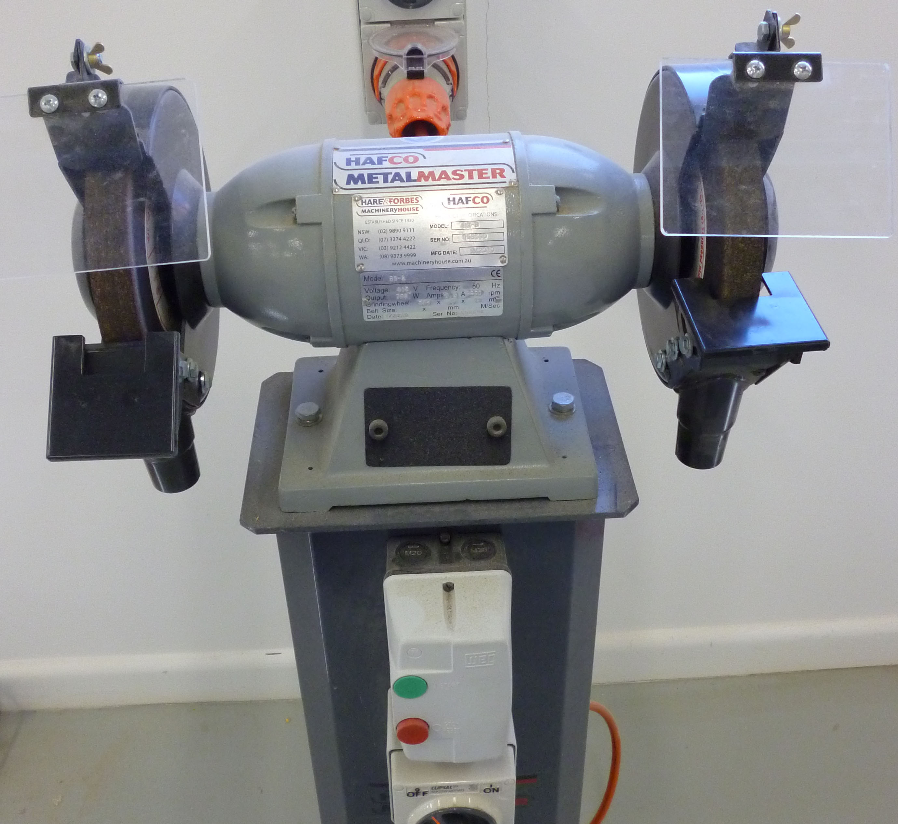
DO NOT use this machine unless you have had instruction and training
in its safe use and operation.

Teacher permission MUST be given

to operate this machine.
The risk of injury when using this machine is SUBSTANTIAL

IDENTIFIED RISKS AND HAZARDS
Hazards that may arise when operating the grinder include:
- moving and rotating parts (wheel disintegration)
- movement of the workpiece
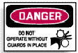
- inhalation of dust particles
- electrocution from power faults or faulty equipment
- burns from hot materials or friction
- hand and finger injuries from rotating wheels
- noise

PRE-OPERATIONAL SAFETY
- The isolating switch should be in the OFF position. The grinding machine must be isolated from the main electricity supply when not in use.
- Check that the abrasive wheel is suitable for the workpiece to be grinded.
- Check the condition of the abrasive wheel. It should be kept in good condition at all times and free of cracks or chips.
- All guards and shields must be correctly fitted and secured.
- Check all adjustments and tool rest settings carefully before commencing any grinding operation.
- The grinding machine and work area should be clean and free of scrap and other obstacles.

OPERATING SAFETY PRECAUTIONS
- Off-cuts and metal swarf must not be removed from the tool rest with the hands when the wheel is rotating.
- The operator should never stand directly in line with the grinding wheel.
- The workpiece should never be forced into the wheel.
- The grinder should never be left unattended with the power switched on.

 |  |  |  |  |  |  | 



