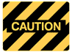
SAFE OPERATING PROCEDURE
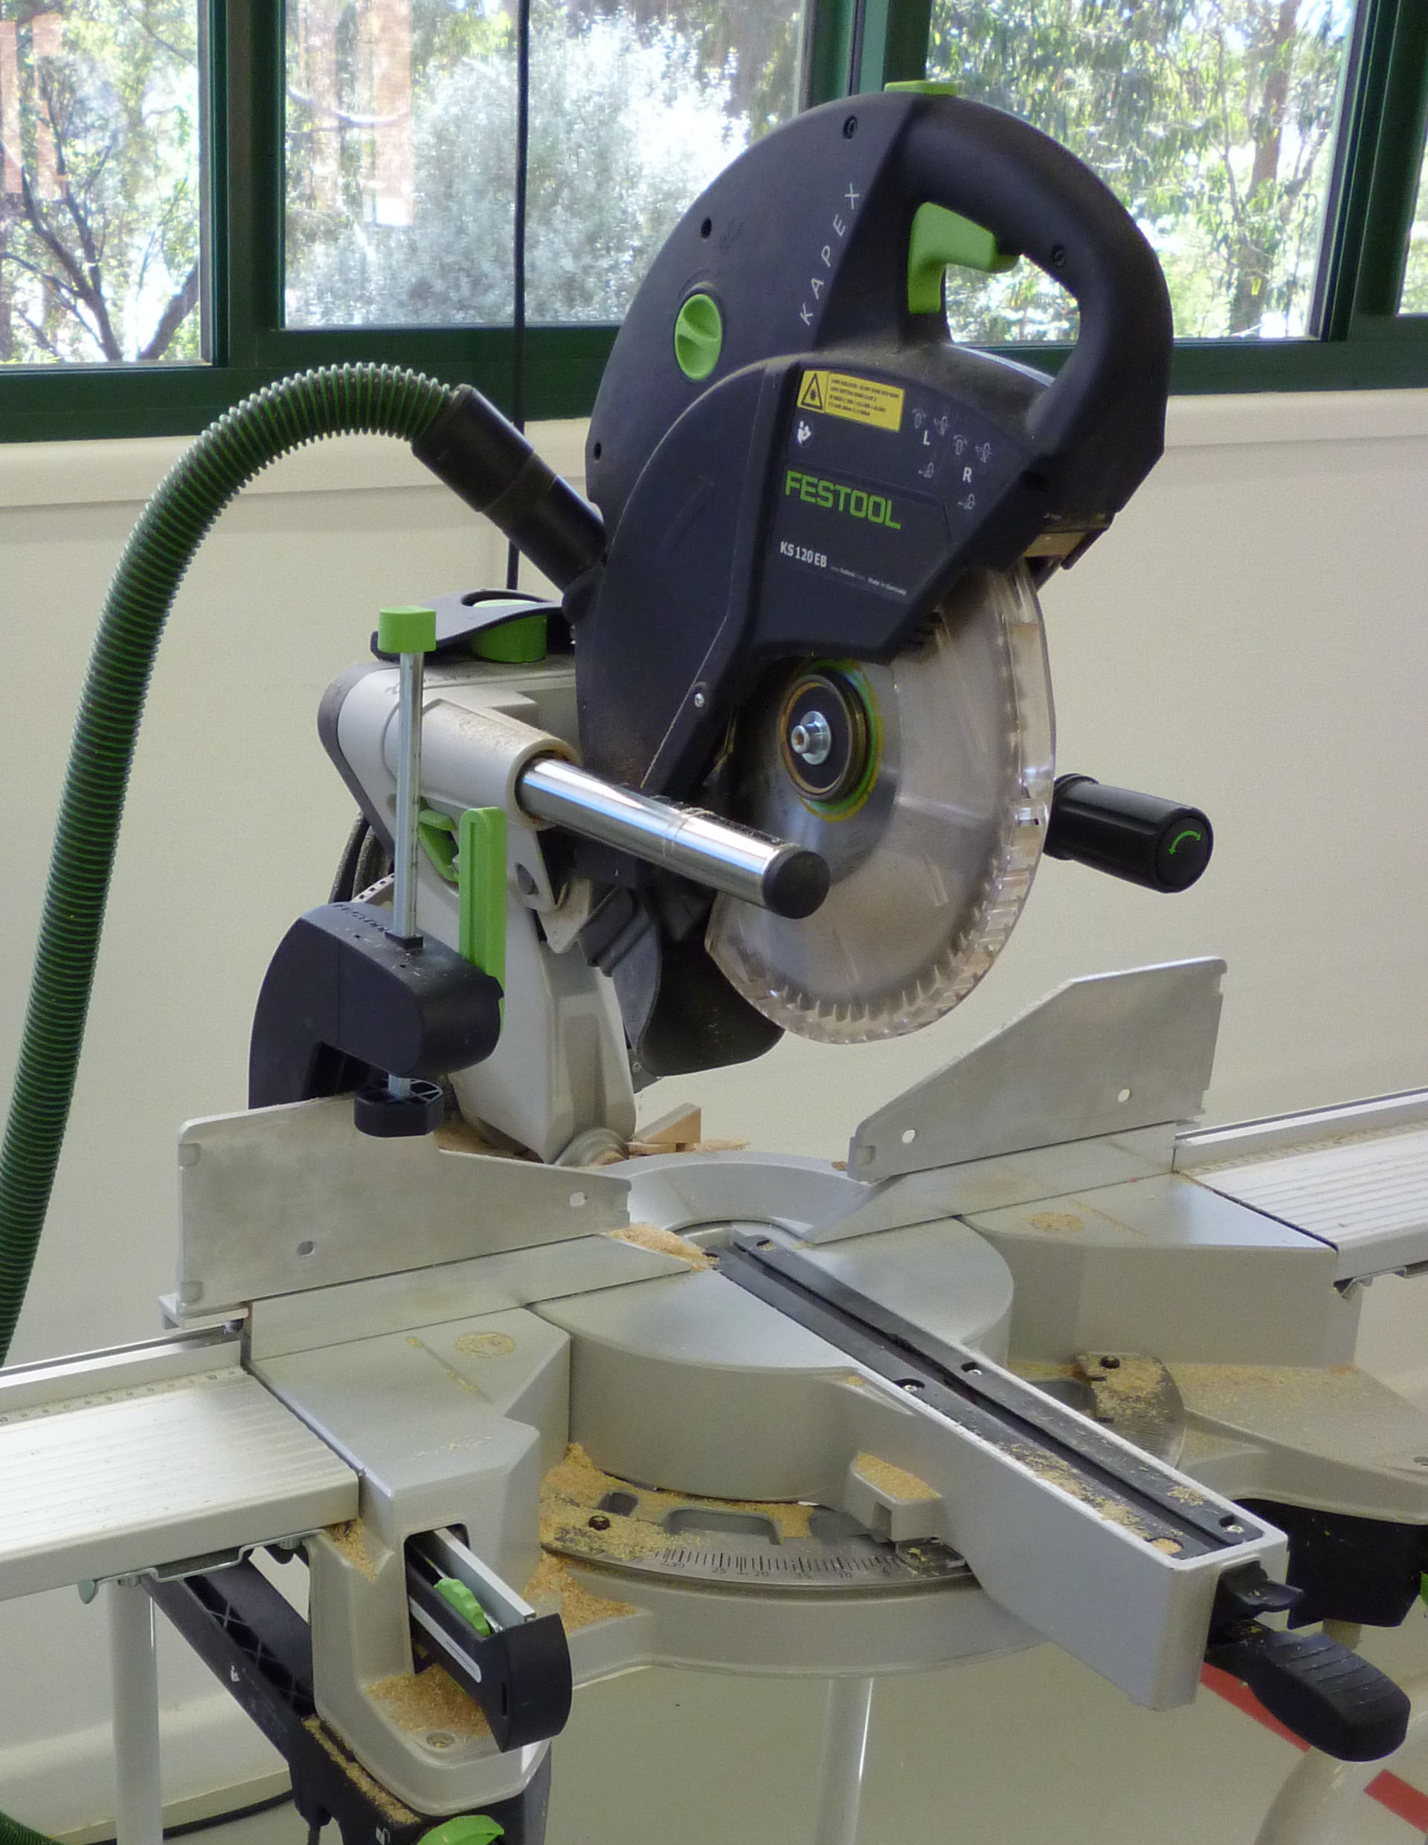

Drop Saw
DO NOT use this machine unless you have had instruction and training
in its safe use and operation.

Teacher permission MUST be given

to operate this machine.
The risk of injury when using this machine is VERY HIGH

IDENTIFIED RISKS AND HAZARDS
Hazards that may arise when operating the drop saw include:
- movement of the workpiece
- electrocution from power faults, faulty equipment or incorrect use
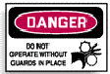
- ejection of waste materials from cutting blades
- hand and finger injuries from rotating blades, spindles or pulleys
- inhalation of dusts
- noise from high speed cutters

PRE-OPERATIONAL SAFETY
- The isolating switch should be kept in the OFF position while the saw is not being used. The saw must be isolated from the main electricity supply.
- The blade should be fitted with the teeth facing in the direction of the blade rotation. This holds the material against the fence during the cutting operation.
- The blade should be sharp, undamaged and square to the table for docking operations.
- Guards must be fitted, correctly adjusted, secured where necessary or be rotating freely depending on the machine.
- The fence should be square to the table and locked in position where necessary.

OPERATING SAFETY PRECAUTIONS
- The operator should never stand directly in line with the saw blade.
- The saw should be operated with the hand that does not require the operator's body to be in line with the blade.
- The blade should never be forced into the material. Allow the blade to cut at its own speed.
- The saw should always be returned to a non-cutting position after each cut is made. The saw should never be left unattended with the power switched on.
- Material should never be left on the table away from the fence and in line with the saw blade.
- Off-cuts and saw dust must not be removed from the table with the hands when the blade is rotating.
 |  |  |  |  |  |  | 



