Trundle Central School
First Aid Information

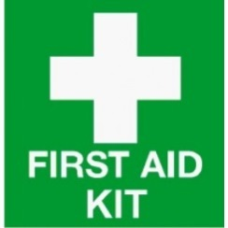
First Aid Kits are located:
Front Office, WAP Office, Science Lab,
Industrial Tech Room, Hospitality Room, Primary
Staff Room, Agriculture Plot, Library and Art Room

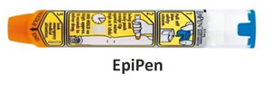
Adrenaline Auto-injectors are located:

General use pen/s (Epipen):
Main Office, Primary Staff Room, Hospitality Room and Agriculture Shed

Student prescribed pen/s: At the School Office or with the Student if required by their Health Care Plan.

Our designated First Aid Officer/s are:

Inst photo of First Aid Officer here
Name: Anne Mawbey/
Insert photo of First Aid Officer here
Lubke Prebendarcik
Position: SAO

Contact details: 68921303

Individual Health Care Plans are located:
School Office: 68921303

Note: Teachers and Student Learning Support Officers must be familiar with any Individual Health Care Plans for students in their care.

Procedure for obtaining First Aid for staff, students and others:
- Minor injury or health condition: All staff should respond to an incident commensurate with their level of training. If safe to do so the injured person may be taken by a staff member to the first aid officer for additional treatment once first aid has been provided.
- Serious injury or health condition: All staff should respond to an incident commensurate with their level of training. First person on the scene should ring Emergency Services if required. All appropriate PPE and contamination risk management plans should be adhered to. Office and First aid officer notified so gates can be opened for Emergency vehicles. Individual health care plans should be followed if applicable.
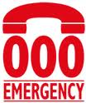
First aid treatment must be recorded.
In an Emergency

