
SAFE OPERATING PROCEDURE

Portable Router (Plunge Type)
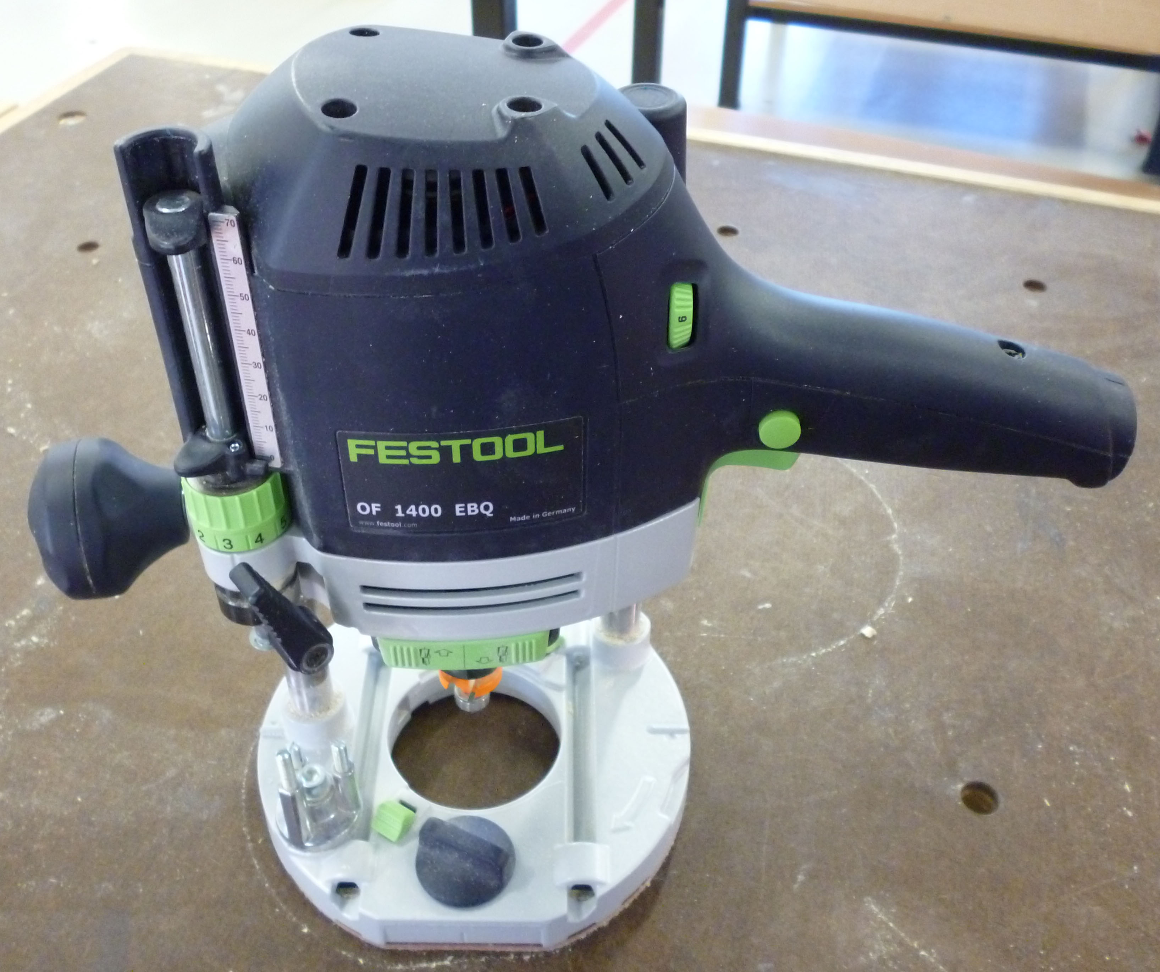
DO NOT use this power tool unless you have had instruction and training
in its safe use and operation.

Teacher permission MUST be given

to operate this power tool.
The risk of injury when using this machine is SUBSTANTIAL

IDENTIFIED RISKS AND HAZARDS
Hazards that may arise when operating the plunge router include:
- moving and rotating parts (bits and tool disintegration)
- movement of the workpiece
- inhalation of dust particles
- electrocution from power faults, faulty equipment or incorrect use

PRE-OPERATIONAL SAFETY
- Before using the router, examine the power cord, extension lead, plugs, sockets and power outlet for damage.
- Check the router bit carefully for cracks or damage before installing it into the router spindle.
- Always inspect the workpiece to ensure that there aren't any items which might damage the bit or cause injury to the operator.
- Secure and support the workpiece using clamps or bench vices.

OPERATING SAFETY PRECAUTIONS
- Keep fingers and hands clear of moving parts and the rotating bit.
- Always keep the power cord clear of moving parts and the rotating bit.
- Ensure that material being worked on is well supported or held securely where necessary.
- Do not strain the power cord especially by lifting or dragging the router by the cord, or by pulling on the cord to remove the plug from the power outlet.
- Never operate Routers in wet or damp conditions.
- Hold the router firmly with both hands and keep the hands and fingers away from the rotating spindle and router bit.
- Watch for vibration or wobbling as this could indicate an improperly installed router bit.
- Do not leave the Router running unattended.
- Always position electrical cords with care to avoid trip hazards and to prevent damage to the cord or extension lead.

 |  |  |  |  |  |  | 



