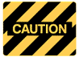
SAFE OPERATING PROCEDURE

Wood Burner
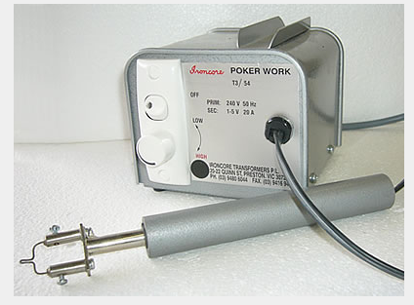 | DO NOT use this appliance unless you have had instruction and training  in its safe use and operation.  Teacher permission MUST be given  to operate this appliance.
The risk of injury when using this machine is LOW

IDENTIFIED RISKS AND HAZARDS

Hazards that may be encountered when using the wood burner include:
- burns from the tip
- fire from protective paper catching alight
- electrical faults
Burns can occur from touching hot metal parts on the heater. Use caution when handling the heater - especially when packing away after a bending operation.

PRE-OPERATIONAL SAFETY

- Always check that the heater and its electrical cord are in good working order.
- Check all adjustments and settings carefully before commencing any heating
operation.
- Make sure the heater is turned off before making adjustments.
- The work area should be clean and free of equipment, rubbish and other obstacles.
- Adjust the temperature correctly. Consult labels for manufacturer’s suggestions.

OPERATING SAFETY PRECAUTIONS

- Allow the heater to reach maximum temperature before applying the workpiece.
- Keep hands well away from the tip when operating.
- Never leave the heater unattended when turned on.
- Keep fingers away from the heater's resting plate whilst heating.

 |  |  |  |  |  |  | 

